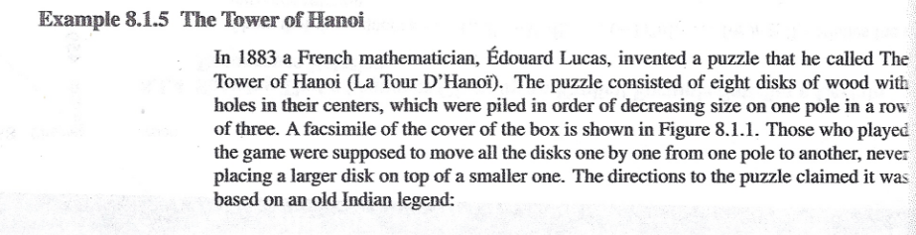

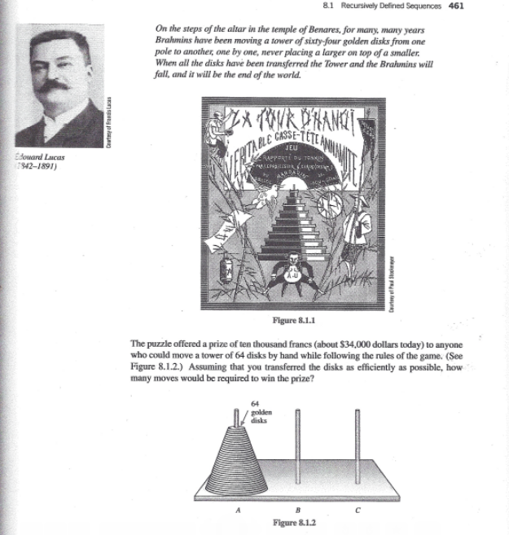

Epp, Susanna S. (2004). Discrete Mathematics with Applications, Third Edition. Thomson Learning, Inc.